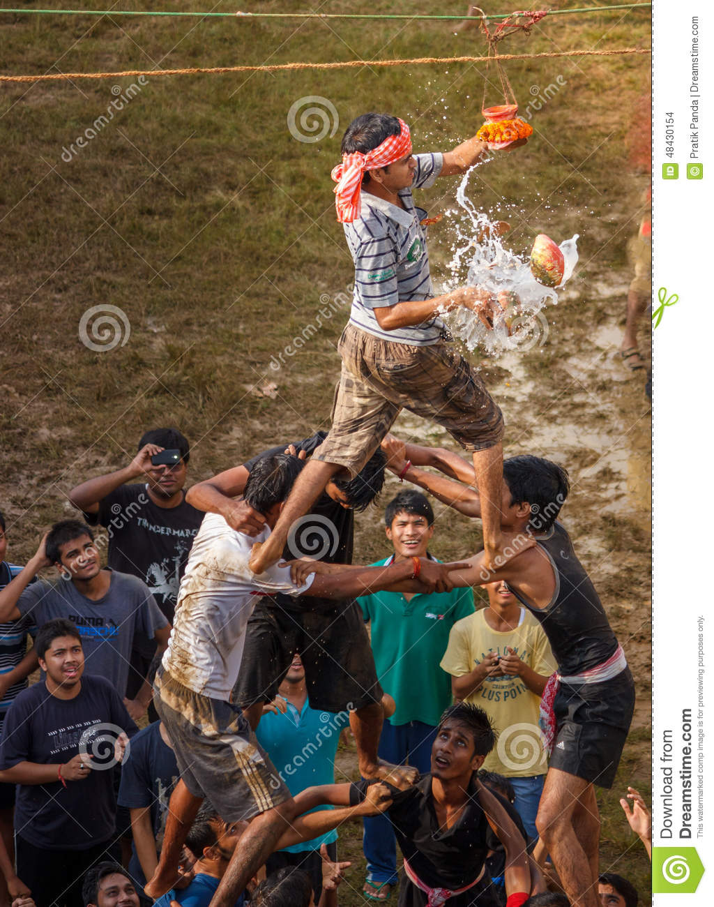

* In the above image you can see the (Janamasthmi celebration Matki fod competition).
* So from this we can say that there are some tasks you can not do by yourself, Everybody needs a helping hand at some point of their life.
* And performing a task together is a great thing and develop teamwork among all the members weather it is on some project or it can be a game or can be anything which require teamwork.